**Program No.06**

**Program title** *Temperature sensor*

**Aim**

To create a digital temperature conversion

**Hardware Required**

Arduino board

Temperature sensor (tmp36)

**Circuit**

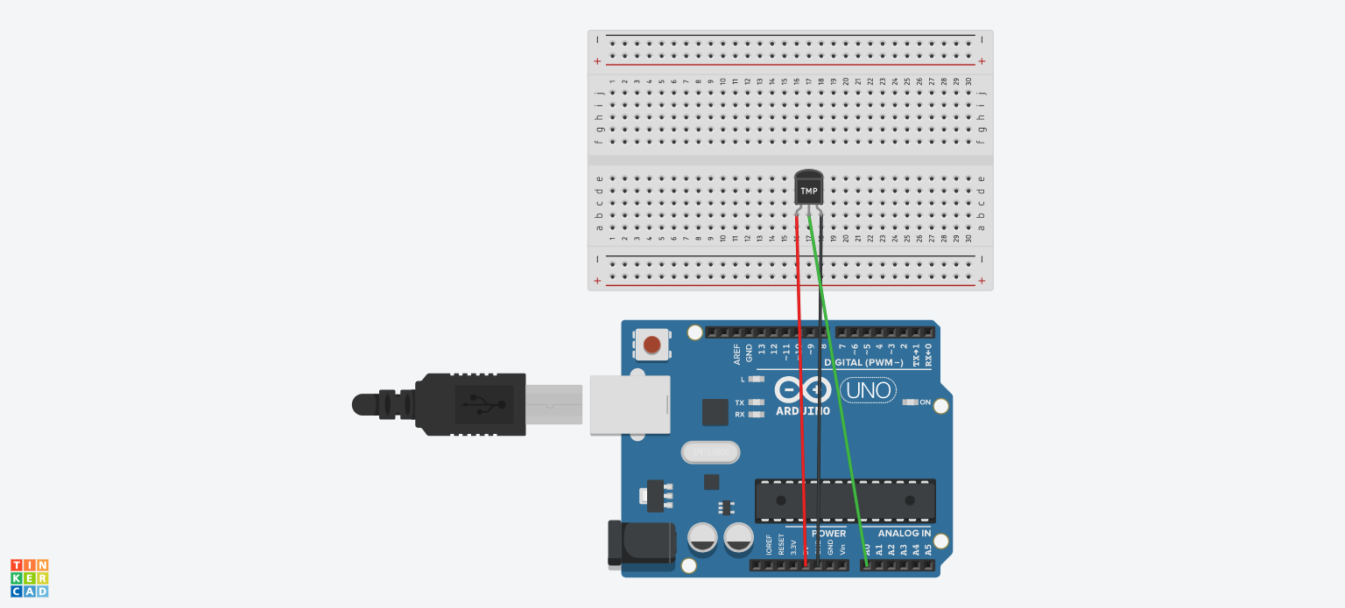

**Code**

int value;

void setup()

{

Serial.begin(9600);

}

void loop()

{

int value=analogRead(A0);

float milivolt=(value/1024.0)*5000;

float celsius=milivolt/10;

Serial.print("\ncelsius=");

Serial.print(celsius);

float fahrenhiet=((celsius*9)/5)+32;

Serial.print("\nfahrenhiet=");

Serial.print(fahrenhiet);

delay(1000);

}

**Observation**

Celsius Is converted to fahrenhiet